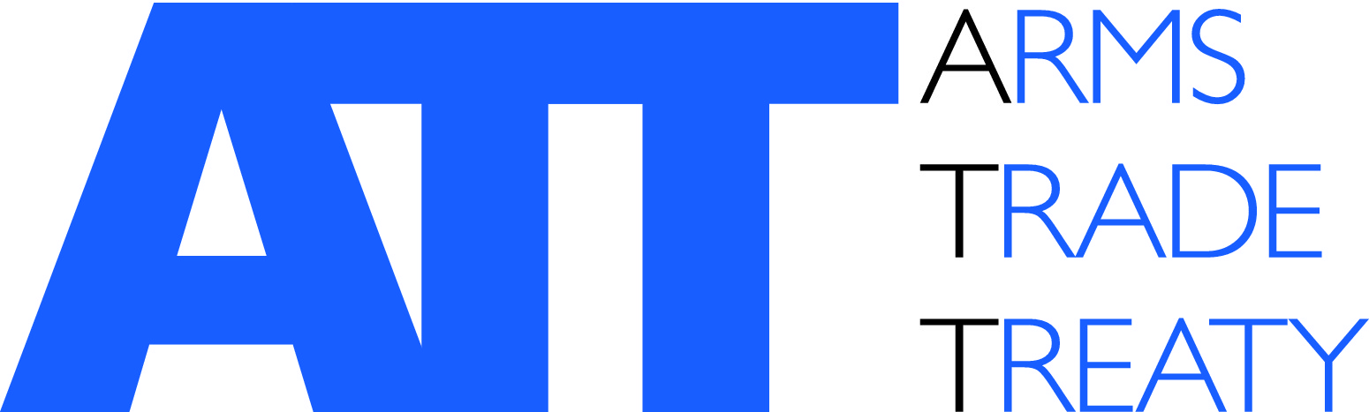 | Issued by the ATT Secretariat

Eighth Conference of States Parties to the Arms Trade Treaty (CSP8)

SIDE EVENT - PROPOSAL FORM

Monday 22 – Friday, 26 August 2022

Title: | Title of the side event
Organizer: | Name of the organization(s) and any government(s) hosting the event
Date →:  Room↓: | Monday  22 August | Tuesday  23 August | Wednesday  24 August | Thursday  25 August | Friday  26 August
Room B
(108 persons)
Room C
(108 persons)
Room E
(60 persons)
Room F
(60 persons)
 | Please indicate in the table above the room you would prefer to hold the side-event in. You may select more than one option, if you have flexibility regarding dates.
Speakers: | List the speakers by name in order of appearance
Start time:
Finish time:
Language:
Technical requirements: | Do you require audio-visual equipment? Yes No  Please specify:
Interpretation: | Do you intend to provide interpretation? Yes No
Catering: | Do you intend to provide catering? Yes No
Address for invoice: | Name and email address of the person the invoice for any additional equipment should be sent to
Focal point: | Name and email address
Description:

Please note the following:
- Interpretation: Interpretation equipment is available in all rooms;
- Capacity: Rooms B & C hold 108 persons; Rooms E & F hold 60 persons;
- Technical equipment: Use of audio-visual equipment is charged at CHF 260.- per room. If you require additional equipment or room configuration, additional costs will be incurred.

Please submit this form to Elizabeth O’Brien, ATT Secretariat, at: elizabeth.obrien@thearmstradetreaty.org by 29 July 2022.

